Using Flat Rate Jobs in ROM: This topic covers how to use a flat-rate job on a new repair order in ROM.

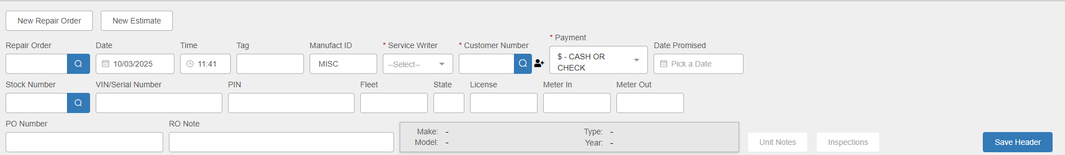

Header Fields:

Repair Order: This field will hold the RO number. You only need to fill in a new RO number if you do not have your system set to auto-assign RO numbers, or if you have a paper RO that already has an assigned number on it. If you have the auto-assign function turned on in Service Options & Defaults (SOD), the field will automatically fill in with a number once you finish creating the header. NOTE: You can also use the field to look up and open an existing repair order.

Date: This field will default to the current date, but you may change it by entering a new date or selecting one from a calendar.

Time: This field will default to the time when you started creating the new order, but you may change it by entering a new time in the field. The clock is set to military time (1-24 instead of 1-12), and the field will reject any entry that does not represent an actual time of day.

Tag: This field is currently an informational field only – not required.

Manufact ID: This field holds the manufacturer ID for the unit being repaired. It defaults to “MISC.”

Service Writer: Type in the service writer’s ID or select it using the dropdown.

Customer Number: Enter the customer’s number or type in all/part of the customer’s name to look it up.

- If you are applying the job to an existing RO, see the pop-up box of open repair orders that appears for the customer when you select them.
- If you are applying the job to a new RO, click on the Start New RO button to bypass the customer’s preexisting RO list should one pop up.
- Enter your designated Warranty customer number (typically 00007) if applying the job to a Warranty RO.
- Enter your designated Internal customer number (typically 00004) if applying the job to an Internal RO.

Payment: The Method of Payment (MOP) defaults based on the customer’s Master record in Enter Customer Information (ECI). This is only a suggested payment option. During Settlement, you will still have the chance to change it, though you need to have one selected in the Header to create the RO.

Date Promised: If your dealership’s policy is to set a promise or target date for repair completion, you can enter that date in this field. If entered, it will print on Tech Copy and Invoice. You can otherwise leave it blank.

Stock Number: Enter the Stock Number if known or use the Search function to look one up. If you have already selected the customer at this point, the Search button will open Customer Equipment Maintenance (CEM) to let you see only units belonging to the selected customer. If the unit is not already on record, you will be able to use this screen to add it.

VIN/Serial Number: This field is not required, but you can enter the unit’s VIN or serial number here.

PIN: If the unit has or requires a PIN number, enter it in this field.

Fleet, ST, and License: These fields are currently informational fields only – not required.

Meter In/Out: Enter information in these fields as required by your dealership’s policies and/or system settings. These will print on Tech Copy and Invoice.

PO Number: Enter a purchase order number here if needed.

RO Note: Add a short note here if desired.

Make/Model/Type/Year: These fields will automatically fill in if you select a unit for the RO.

Unit Notes: This button will activate once you select a unit for the RO. It will let you view the unit’s notes as recorded in the system.

Inspections: Clicking this button will redirect you to the Record360 login page. Once you log in with your Record360 credentials, you will be able to view any inspections for the unit recorded in the Record360 system.

Save Header: Press this button to save the header information. The Repair Order number has been assigned (you will see the field grayed out to prevent you as the user from changing it). The Header will also now change to its locked status:

Adding the Flat Rate Job: Begin a new condition on the RO. On a new RO, this will be Condition 001.

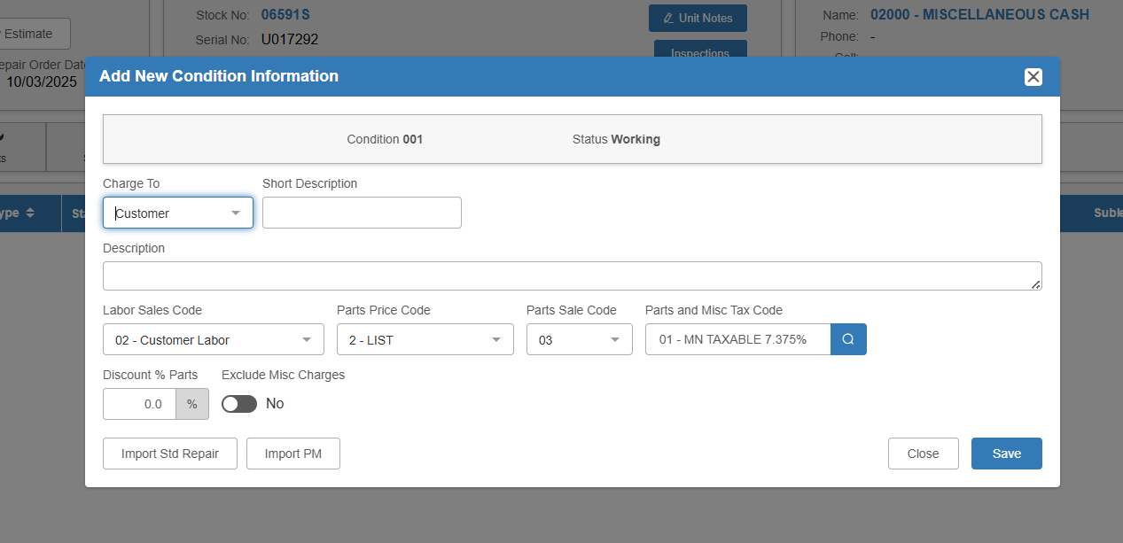

Click the Import Std Repair button to open the Standard Jobs screen, which shows a list of all flat-rate jobs in the system.

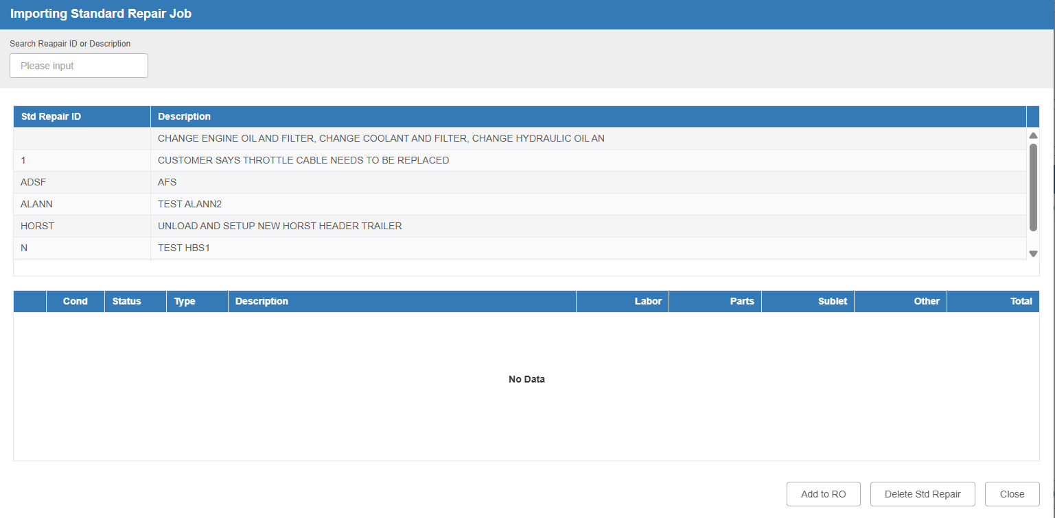

Choose a Flat Rate Job from the screen or use the search feature to located the desired one. Click on the job entry to see a preview of the Condition details.

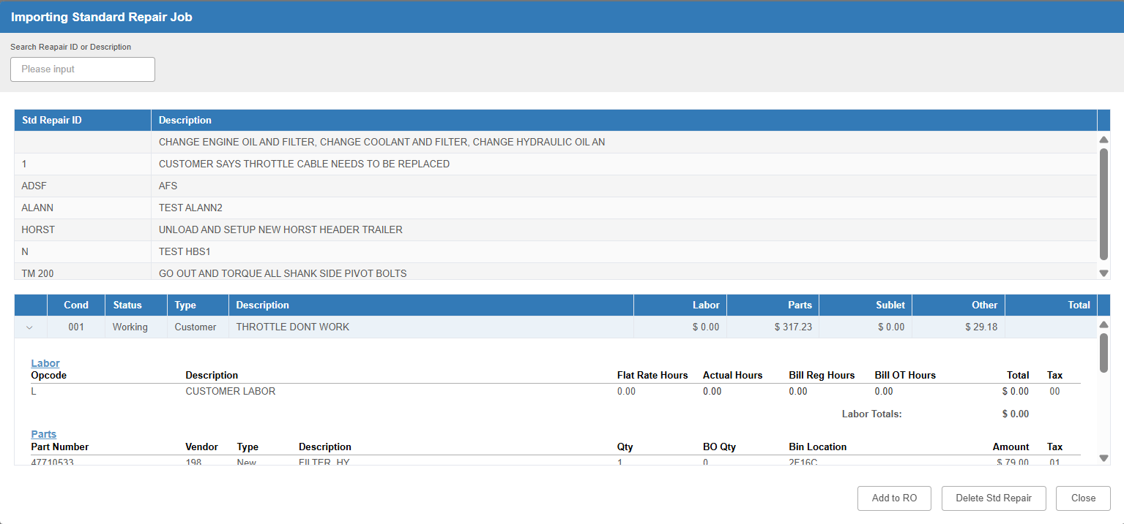

Click the Add to RO button to add the selected job to the repair order. The job will now appear in the Condition line on the main screen.

